Streams Assignment

Implement Snowflake Streams for Sales Data Processing

A retail company receives sales data in a staging table. The company wants to load this data into a final reporting table. After the initial load, only newly inserted or updated records should be processed using Snowflake Streams.

You need to create the database, tables, stream object, insert records, consume stream data, and update the final table using stream changes.

Task 1: Create Database

Create a transient database named:
STREAMS_DB

CREATE OR REPLACE TRANSIENT DATABASE STREAMS_DB;

Task 2: Create Raw Sales Staging Table

Create a table named:

SALES_RAW_STAGING

The table should contain the following columns:

id
product
price
amount
store_id

Use suitable data types.

CREATE OR REPLACE TABLE STREAMS_DB.PUBLIC.SALES_RAW_STAGING (
id int,
product string,
price decimal(10,2),
amount int,
store_id int
);

Task 3: Insert Initial Sales Data

Insert the following five records into SALES_RAW_STAGING:

id product price amount store_id
1 Banana 1.99 1 1
2 Lemon 0.99 1 1
3 Apple 1.79 1 2
4 Orange Juice 1.89 1
5 Cereals 5.98 2 1

INSERT INTO STREAMS_DB.PUBLIC.SALES_RAW_STAGING VALUES
(1, 'Banana', 1.99, 1, 1),
(2, 'Lemon', 0.99, 1, 1),
(3, 'Apple', 1.79, 1, 2),
(4, 'Orange Juice', 1.89, null, 1),
(5, 'Cereals', 5.98, 2, 1);

Task 4: Create Store Table

Create a table named:

STORE_TABLE

The table should contain:

store_id
location
employees

CREATE OR REPLACE TABLE STREAMS_DB.PUBLIC.STORE_TABLE (
store_id int,
location string,
employees int
);

Task 5: Insert Store Data

Insert the following records into STORE_TABLE:

store_id location employees
1 Chicago 33
2 London 12

INSERT INTO STREAMS_DB.PUBLIC.STORE_TABLE VALUES
(1, 'Chicago', 33),
(2, 'London', 12);

Task 6: Create Final Sales Table

Create a table named:

SALES_FINAL_TABLE

The table should contain:

id
product
price
amount
store_id
location
employees

This table will store sales data along with store location and employee details.

CREATE OR REPLACE TABLE STREAMS_DB.PUBLIC.SALES_FINAL_TABLE (
id int,
product string,
price decimal(10,2),
amount int,
store_id int,
location string,
employees int
);

Task 7: Perform Initial Full Load

Load data from SALES_RAW_STAGING into SALES_FINAL_TABLE.

While loading, join:

SALES_RAW_STAGING

with:

STORE_TABLE

using STORE_ID.

INSERT INTO STREAMS_DB.PUBLIC.SALES_FINAL_TABLE
SELECT
SALES.ID, SALES.PRODUCT, SALES.PRICE, SALES.AMOUNT,
STORE.STORE_ID, STORE.LOCATION, STORE.EMPLOYEES
FROM STREAMS_DB.PUBLIC.SALES_RAW_STAGING SALES
JOIN STREAMS_DB.PUBLIC.STORE_TABLE STORE
ON SALES.STORE_ID = STORE.STORE_ID;

Task 8: Verify Initial Load

Display data from:

SALES_RAW_STAGING;
SELECT * FROM STREAMS_DB.PUBLIC.SALES_RAW_STAGING;
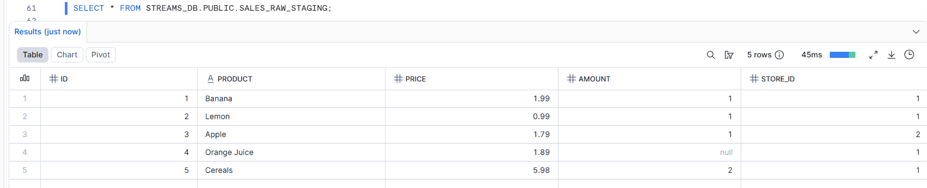

STORE_TABLE;
SELECT * FROM STREAMS_DB.PUBLIC.STORE_TABLE;
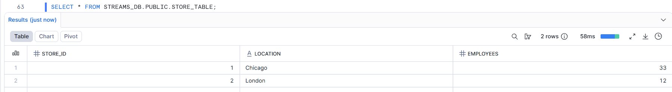

SALES_FINAL_TABLE;
SELECT * FROM STREAMS_DB.PUBLIC.SALES_FINAL_TABLE;
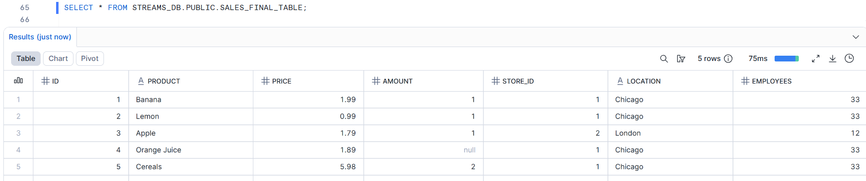

Confirm that SALES_FINAL_TABLE contains 5 records.
YES

Stream Implementation
Task 9: Create Stream Object

Create a stream named:

SALES_STREAM

on top of:

SALES_RAW_STAGING

CREATE OR REPLACE STREAM STREAMS_DB.PUBLIC.SALES_STREAM
ON TABLE STREAMS_DB.PUBLIC.SALES_RAW_STAGING;

Task 10: View Stream Information

Execute commands to:

Show all streams.
Describe the SALES_STREAM.
DESC STREAM STREAMS_DB.PUBLIC.SALES_STREAM;

Select data from SALES_STREAM.
SELECT * FROM STREAMS_DB.PUBLIC.SALES_STREAM;
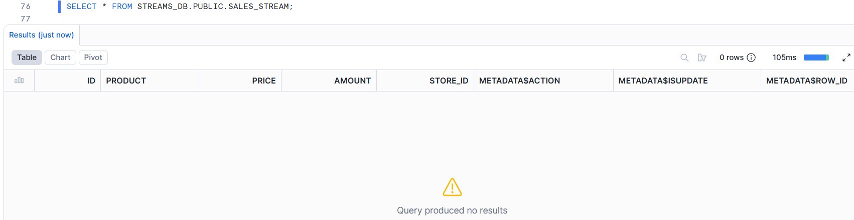

Answer this question:

Why is SALES_STREAM empty immediately after creation?
Insert Change Capture
SALES STREAM IS EMPTY IMMEDIATELY AFTER CREATION BECAUSE THE INSERTIONS WERE EXECUTED BEFORE THE CREATION OF THE STREAM. ONCE THE STREAM IS CREATED, ONLY AFTER THAT THE CHANGES CAN BE CAPTURED FROM THE RAW TABLE.
CHANGE CAPTURE IS A FEATURE OF STREAM, WHICH USES SNAPSHOTS TO COMPARE THE NEW CAHNGES, WHATEVER THE NEW CHANGES ARE THAT ARE NOT APPLIED TO THE FINAL TABLE, STAYS IN THE STREAM OBJECT.

Task 11: Insert New Sales Records

Insert the following two records into SALES_RAW_STAGING:

id product price amount store_id
6 Mango 1.99 1 2
7 Garlic 0.99 1 1

INSERT INTO STREAMS_DB.PUBLIC.SALES_RAW_STAGING VALUES
(6, 'Mango', 1.99, 1, 2),
(7, 'Garlic', 0.99, 1, 1);

Task 12: Check Stream Data

Query SALES_STREAM.

Observe the new records and metadata columns:

METADATA$ACTION
METADATA$ISUPDATE
METADATA$ROW_ID

SELECT id, product, price, amount, store_id,
METADATA$ACTION, METADATA$ISUPDATE, METADATA$ROW_ID
FROM STREAMS_DB.PUBLIC.SALES_STREAM;

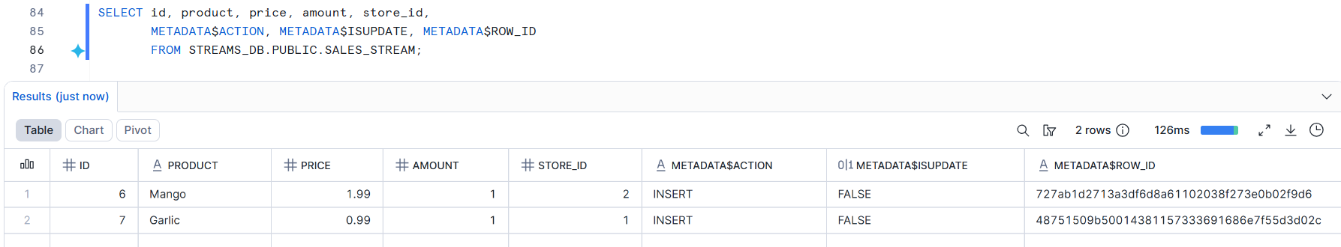

Answer this question:

What value do you see in METADATA$ACTION for newly inserted records?
METADATA$ACTION HAS ‘INSERT’ VALUE FOR THE NEWLY INSERTED RECORDS, AS THE RECORDS WERE INSERTED.
Task 13: Verify Source and Target Tables

Check data in:

SALES_RAW_STAGING;
SELECT * FROM STREAMS_DB.PUBLIC.SALES_RAW_STAGING;
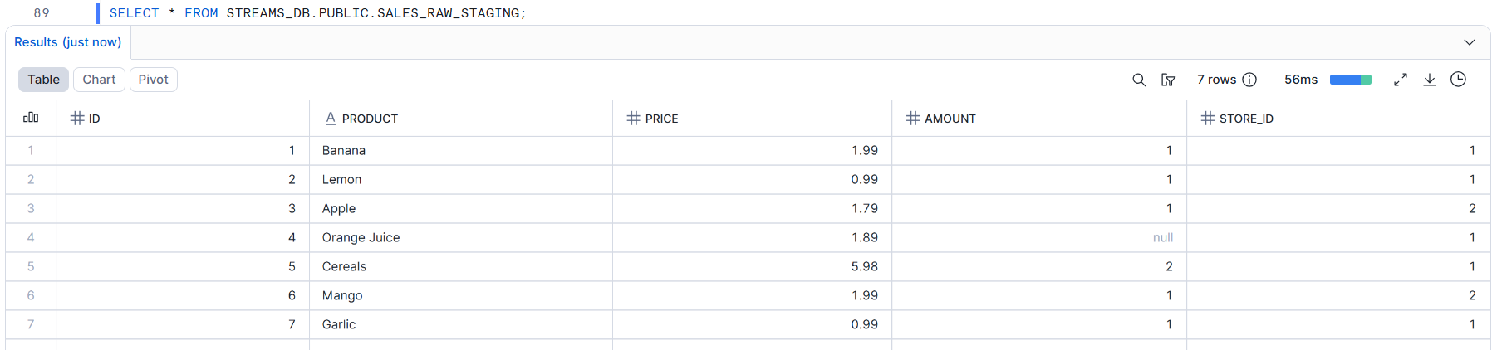

SALES_FINAL_TABLE;
SELECT * FROM STREAMS_DB.PUBLIC.SALES_FINAL_TABLE;
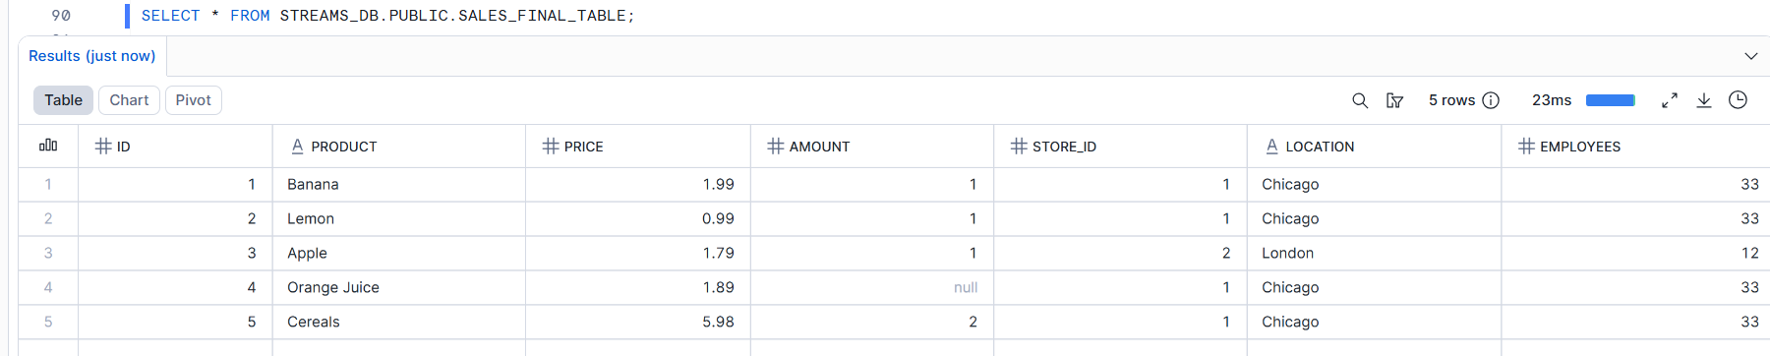

Answer this question:

Are the new records available in SALES_FINAL_TABLE before consuming the stream?
NO, THE NEW RECORDS ARE THERE IS RAW TABLE, BUT NOT IN THE SALES_FINAL_TABLE, SINCE WE HAVE NOT COSUMED THE STREAM.

Task 14: Consume Stream Data

Insert new records from SALES_STREAM into SALES_FINAL_TABLE.

While inserting, join the stream with STORE_TABLE using STORE_ID.

INSERT INTO STREAMS_DB.PUBLIC.SALES_FINAL_TABLE
SELECT
STREAM.ID, STREAM.PRODUCT, STREAM.PRICE, STREAM.AMOUNT,
STORE.STORE_ID, STORE.LOCATION, STORE.EMPLOYEES
FROM STREAMS_DB.PUBLIC.SALES_STREAM STREAM
JOIN STREAMS_DB.PUBLIC.STORE_TABLE STORE
ON STREAM.STORE_ID = STORE.STORE_ID
WHERE METADATA$ACTION = 'INSERT'
AND METADATA$ISUPDATE = FALSE;

Task 15: Verify Stream After Consumption

Query:

SELECT * FROM SALES_STREAM;
SELECT * FROM STREAMS_DB.PUBLIC.SALES_STREAM;
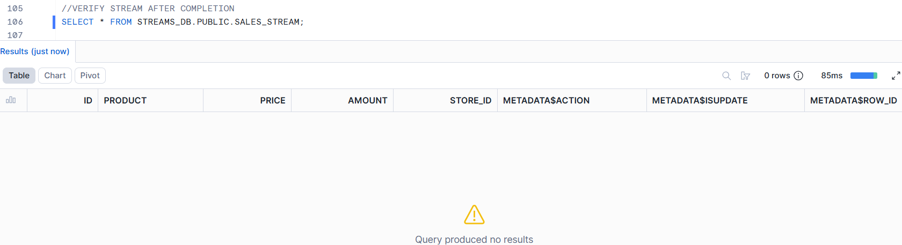

Answer this question:

Why did the stream become empty after inserting data into SALES_FINAL_TABLE?
SINCE THE DATA IS CONSUMED IN THE FINAL TABLE, THE DATA IS REMOVED FROM THE STREAM, SO THAT IF NEW DATA COMES IN STREAM, THE STREAM WON’T RE-CONSUME THE SAME OLD DATA IN THE FINAL TABLE. ONCE THE STREAM IS CONSUMED, THE DATA GETS TRANSFERRED TO THE FINAL TABLE. ONLY THE NEW CHANGES WILL STAY INSIDE THE STREAM.

Second Insert Change Capture
Task 16: Insert More Sales Records

Insert the following two records into SALES_RAW_STAGING:

id product price amount store_id
8 Paprika 4.99 1 2
9 Tomato 3.99 1 2

INSERT INTO STREAMS_DB.PUBLIC.SALES_RAW_STAGING VALUES
(8, 'Paparika', 4.99, 1, 2),
(9, 'Tomato', 3.99, 1, 2);

Task 17: Consume Second Stream Data

Consume the newly captured stream records and insert them into SALES_FINAL_TABLE.

INSERT INTO STREAMS_DB.PUBLIC.SALES_FINAL_TABLE
SELECT
STREAM.ID, STREAM.PRODUCT, STREAM.PRICE, STREAM.AMOUNT,
STORE.STORE_ID, STORE.LOCATION, STORE.EMPLOYEES
FROM STREAMS_DB.PUBLIC.SALES_STREAM STREAM
JOIN STREAMS_DB.PUBLIC.STORE_TABLE STORE
ON STREAM.STORE_ID = STORE.STORE_ID
WHERE METADATA$ACTION = 'INSERT'
AND METADATA$ISUPDATE = FALSE;

Task 18: Verify Final Insert Output

Display data from:

SALES_FINAL_TABLE;
SELECT * FROM STREAMS_DB.PUBLIC.SALES_FINAL_TABLE;
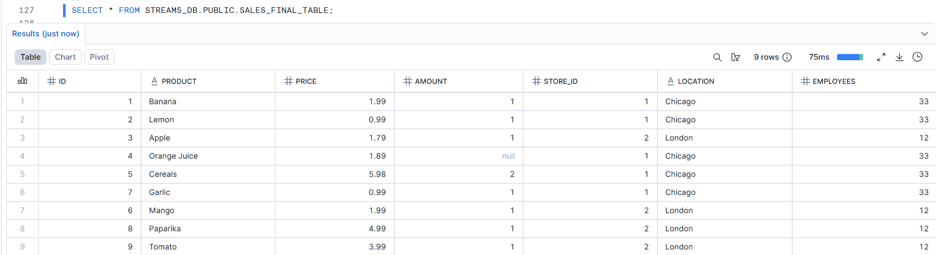

SALES_RAW_STAGING;
SELECT * FROM STREAMS_DB.PUBLIC.SALES_RAW_STAGING;
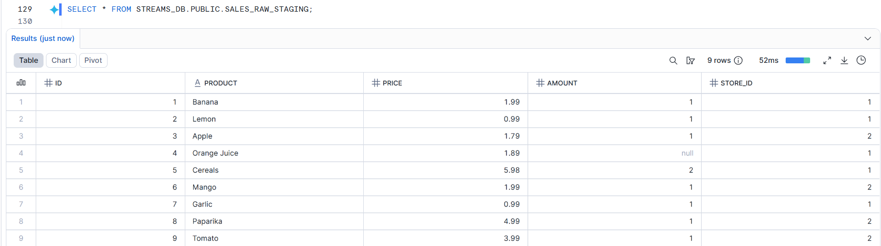

SALES_STREAM;
SELECT * FROM STREAMS_DB.PUBLIC.SALES_STREAM;
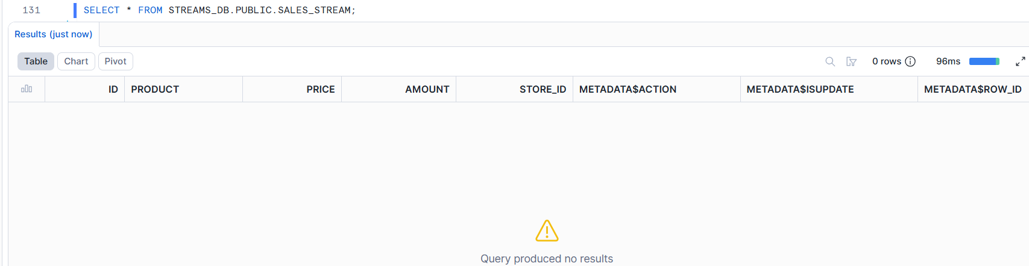

Answer:

How many records are now available in SALES_FINAL_TABLE?
ALL 9 RECORDS

Update Change Capture
Task 19: Check Existing Data Before Update

Display records from:

SALES_RAW_STAGING;
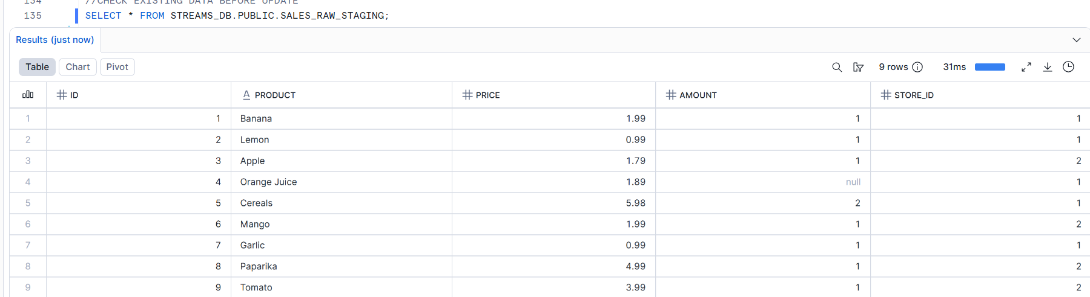

SALES_STREAM;
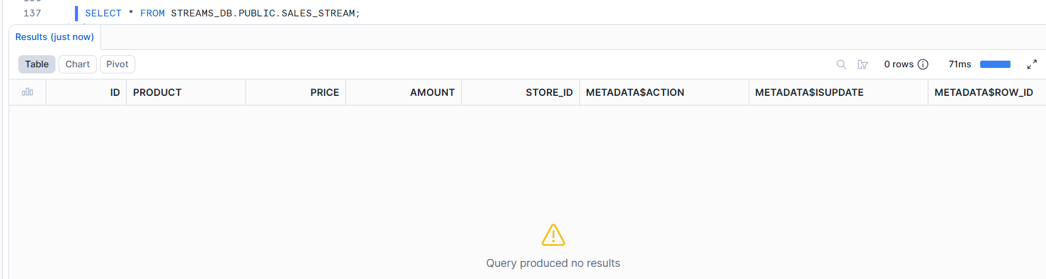

Task 20: Perform First Update

Update the product name:

Banana

to:

Potato

in SALES_RAW_STAGING.

UPDATE STREAMS_DB.PUBLIC.SALES_RAW_STAGING
SET PRODUCT = 'Potato' WHERE PRODUCT= 'Banana';

Task 21: Check Stream After Update

Query:

SELECT * FROM SALES_STREAM;
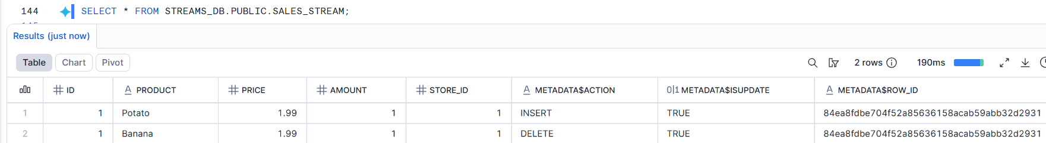

Answer:

How does Snowflake represent an UPDATE operation inside a stream?
SNOWFLAKE REPRESENTS AN UPDAT OPERATION INSIDE A STREAM USING ‘DELETE’ AND ‘INSERT’ OPERATIONS IN SEPARATE RECORDS. IT FIRST TAKE DELETE OPERATION TO DELETE OLD RECORD, THEN INSERT OPERATION WITH NEW UPDATED VALUE INSERTED. ISUPDATE VALUE AS TRUE IN BOTH RECORDS, WHICH INDICATES THAT IT IS NOT A NORMAL DELETE AND INSERT OPERATION, BUT AN UPDATE OPERATION INSTEAD.

Task 22: Consume Update Using MERGE

Use a MERGE statement to update the corresponding record in SALES_FINAL_TABLE.

Condition:

Match records using ID
Update only records where METADATA$ACTION = 'INSERT'
and METADATA$ISUPDATE = TRUE

Update the following columns:

product
price
amount
store_id

MERGE INTO STREAMS_DB.PUBLIC.SALES_FINAL_TABLE F
USING (
SELECT ID, PRODUCT, PRICE, AMOUNT, STORE_ID
FROM STREAMS_DB.PUBLIC.SALES_STREAM
WHERE METADATA$ACTION = 'INSERT'
AND METADATA$ISUPDATE = 'TRUE'
) S
ON F.ID = S.ID
WHEN MATCHED THEN
UPDATE SET
F.ID = S.ID,
F.PRODUCT = S.PRODUCT,
F.AMOUNT = S.AMOUNT,
F.STORE_ID = S.STORE_ID;

Task 23: Verify First Update

Display data from:

SALES_FINAL_TABLE;
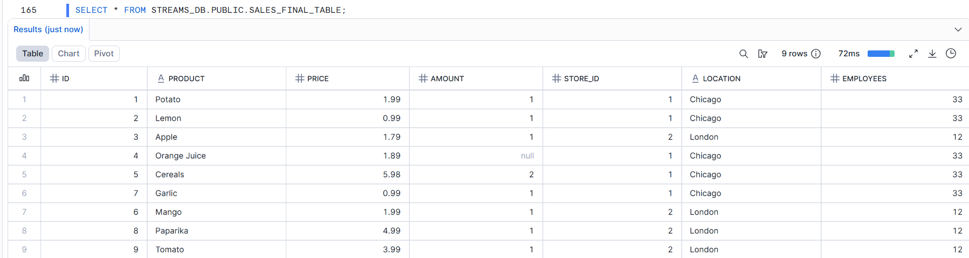

SALES_RAW_STAGING;
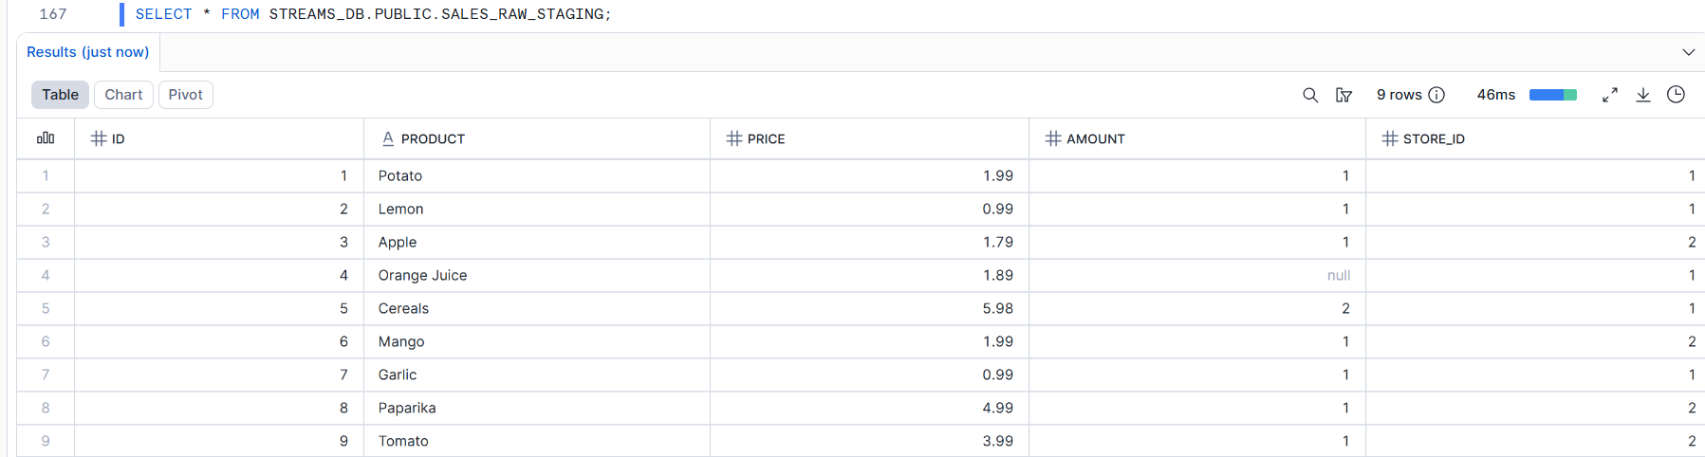

SALES_STREAM;
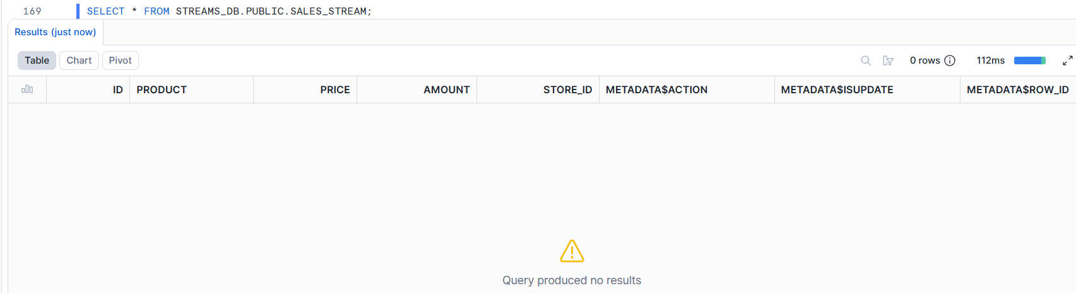

Answer:
Is Banana changed to Potato in SALES_FINAL_TABLE?
YES
Second Update Change Capture

Task 24: Perform Second Update

Update the product name:

Apple

to:

Green apple

in SALES_RAW_STAGING.

UPDATE STREAMS_DB.PUBLIC.SALES_RAW_STAGING
SET PRODUCT = 'Green Apple' where PRODUCT= 'Apple';

Task 25: Consume Second Update Using MERGE

Use a MERGE statement to update the changed record in SALES_FINAL_TABLE.

MERGE INTO STREAMS_DB.PUBLIC.SALES_FINAL_TABLE F
USING (
SELECT STREAM.ID, STREAM.PRODUCT, STREAM.PRICE, STREAM.AMOUNT, STREAM.STORE_ID,
STORE.LOCATION, STORE.EMPLOYEES
FROM STREAMS_DB.PUBLIC.SALES_STREAM STREAM
JOIN STREAMS_DB.PUBLIC.STORE_TABLE STORE
ON STREAM.STORE_ID = STORE.STORE_ID
WHERE METADATA$ACTION = 'INSERT'
AND METADATA$ISUPDATE = TRUE
) S
ON S.ID = F.ID
WHEN MATCHED THEN
UPDATE SET
F.ID = S.ID,
F.PRODUCT = S.PRODUCT,
F.PRICE = S.PRICE,
F.AMOUNT = S.AMOUNT,
F.STORE_ID = S.STORE_ID,
F.LOCATION = S.LOCATION,
F.EMPLOYEES = S.EMPLOYEES;

Task 26: Verify Final Output

Display data from:

SALES_FINAL_TABLE;

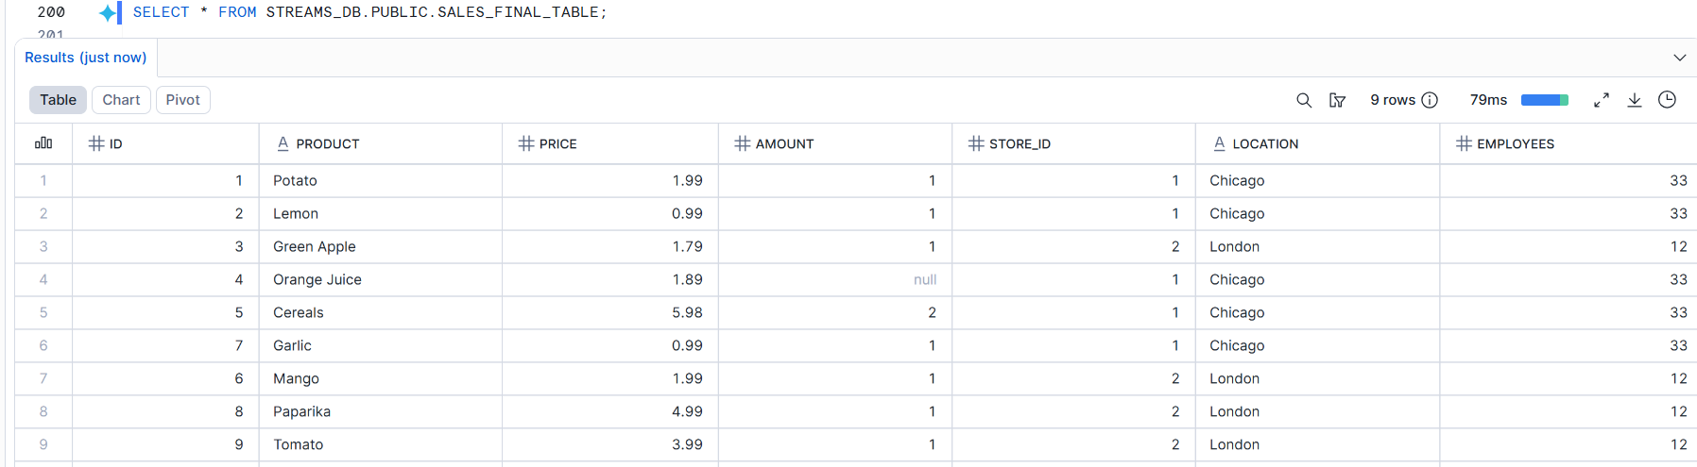

SALES_RAW_STAGING;

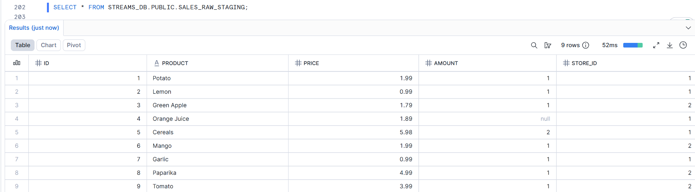

SALES_STREAM;

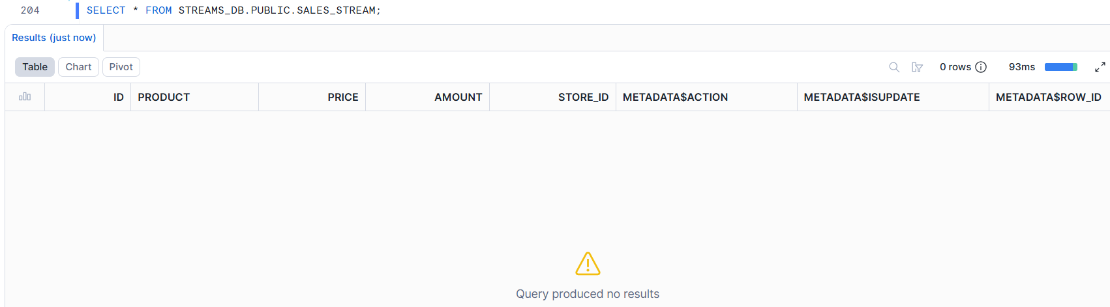

Answer:

Is Apple changed to Green apple in SALES_FINAL_TABLE?
YES

